**Project Design Phase-II Technology Stack (Architecture & Stack)**

|  |  |
| --- | --- |
| Date | 03 October 2022 |
| Team ID | PNT2022TMID34648 |
| Project Name | Personal Expense Tracker |
| Maximum Marks | 4 Marks |

**Technical Architecture:**

Technical Architecture (TA) is **a form of IT architecture that is used to design computer systems**. It involves the development of a technical blueprint with regard to the arrangement, interaction, and interdependence of all elements so that system-relevant requirements are met.

The Deliverable shall include the architectural diagram as below and the information as per the table1 & table 2 .

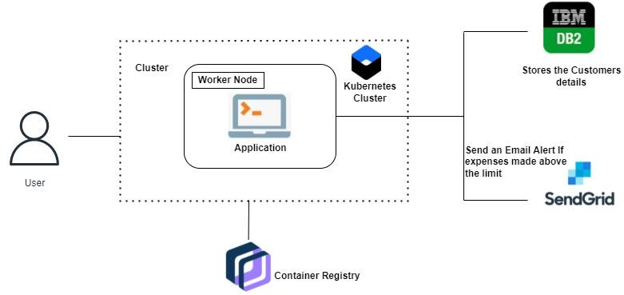

**Table-1 : Components & Technologies:**

|  |  |  |  |
| --- | --- | --- | --- |
| **S.No** | **Component** | **Description** | **Technology** |
| 1. | User Interface | How user interacts with application for example Web UI, Mobile App etc.. | HTML, CSS, JavaScript in Python Flask |
| 2. | User Login | Using Google account or an account in the app server the user can login. | Google Oauth for Google Signin. Hashed password in DB |
| 3. | Graph Visualization | Rendering plots and graphs based on the user spending data. | Seaborn, Mathplotlib |
| 4. | Database | Data Type, Configurations etc. | NoSQL database can be used as it  promotes flexible structuring of data |
| 5. | Cloud Database | Database Service on Cloud | IBM DB2 is used to store the user details and the data entries |
| 6. | Google OAuth | OAuth 2.0 is the authorization protocol used by Google APIs. | Enables login through Google account, making the application accessible |
| 7. | Cloud Deployment | Application Deployment on IBM Cloud Server | Docker and Kubernetes is used for deployment as it promises scalability and high availability |
| 8. | SendGrid | SendGrid offers the use of their mail servers to send your emails. This is an excellent option for sending large volumes of emails, where having to do so manually would take a significant amount of time and effort. | SendGrid is used to trigger mail to user emails when a particular condition is met |

|  |  |  |  |
| --- | --- | --- | --- |
| **S.No** | **Characteristics** | **Description** | **Technology** |
| 1. | Open-Source Frameworks | Flask is a lightweight WSGI web application framework. It is designed to make getting started quick and easy, with the ability to scale up to complex applications. It has become one of the most popular Python web application frameworks. | Python Flask Framework |
| 2. | Security Implementations | Passwords cant be stored as plain text so it is hashed and salted | BCrypt |
| 3. | Scalable Architecture | Containerized application is deployed to rapidly increase scale on demand | Docker |
| 4. | Availability, Performance | Kubernetes, also known as K8s, is an open-source system for automating deployment, scaling, and management of containerized applications. | Kubernetes |

**Table-2: Application Characteristics:**